NEIGHBORS IN NEED OF SERVICES, INC. (NINOS)
HEADSTART PROGRAM


Bid Packet for
4 – Utility Cargo Vans w/lift
2021/2022 Model

FY 2021/2022
# 21-RFP-004

Neighbors In Need of Services, Inc. Head Start/Early Head Start
Invitation to Bid

Bid Number# 21-RFP-004
Bid Title: Utility Cargo Vans (4) with Lift Gate 2021/22 Model

Date Due: July 6, 2021 Due No Later Than: 4:00 p.m.
NINOS Inc. Head Start / Early Head Start Program is a private non-profit organization. NINOS Inc. Head Start / Early Head Start Programs provide services to low income families for children from birth to five years of age.
The agency is funded to serve 2,424 children throughout Cameron and Willacy Counties.

The agency is currently seeking bids for its Transportation Content Area for the following: Utility Cargo Vans (4) with Lift Gate 2021/22 Model (See Exhibit “A” for Specifications)

CLOSING SUBMISSION DATE & PUBLIC OPENING
Please submit the following information in a sealed envelope by July 6, 2021 by 4:00 PM. Bid opening will be held on July 7, 2021 at 9:00 a.m. at NINOS Administration office located at 22887 State HWY 345 in Rio Hondo, TX 78583.

INQUIRIES
For further information please call Marco Herrera, Director of CHS marco.herrera@ninosinc.org at (956) 399-9944 or by email marco.herrera@ninosinc.org or Ruben Garcia, Procurement Officer, email ruben.garcia@ninosinc.org

NON-DISCRIMINATION & EQUAL OPPORTUNITY
No person shall on the grounds of race, color, religion, sex, national origin, age, handicap, political affiliation or belief be excluded from participation in, be denied the benefits of, be subjected to discrimination under, or be denied employment in the administration of or in connection with any program or activity funded in whole or in part with funds made available under this contract.

NON-RESPONSIVE PROPOSALS
Proposals may be judged non-responsive and removed from further consideration if any of the following occur:
- The proposal is not received timely in accordance with the terms of this proposal.
- The proposal does not follow the specified format.
- The proposal does not include documentation of accompanying credentials.
- Bid not sealed.
- Bid not returned to Administrative Office, Attn: Tracy Torres

REVIEW PROCESS
NINOS Inc. reserves the right to waive any informalities or to reject any or all proposals submitted and contemplates award of the contract to the responsible offer or with the most advantageous bid.

No bidder may withdraw his bid within 30 days after the actual date of the opening thereof.

NEIGHBORS IN NEED OF SERVICES, INC. HEAD START / EARLY HEAD START

INSTRUCTIONS

Carefully read all instructions, requirements and specifications. Fill out all forms properly and completely. Prior to returning your sealed bid response / submittal, all Addendums - if issued - should be reviewed and downloaded by entering the NINOS, Inc. web site at www.ninosinc.org.

Please return bid in sealed envelope. Be sure that return envelope shows the Bid Number, Description and is marked “SEALED BID”.

RETURN BID TO:

Delivered to the administration office:
Attn: Tracy Torres
22887 State HWY 345
Rio Hondo, TX 78583

Mailed to: VIA UPS or FEDEX delivery Mailed to: VIA USPS
Attn: Tracy Torres Attn: Tracy Torres
22887 State HWY 345 PO BOX 189
Rio Hondo, TX 78583 Rio Hondo, TX 78583

You must sign below in ink failure to sign will disqualify the offer. All prices must be typewritten or written in ink.

Company Name:

Company Address:

City, State, Zip Code:

Telephone: Fax No: E-mail:

Print Name: Signature:

(Your signature attests to your offer to provide the goods and/or services in this bid according to the published provision of this bid.)
Exhibit “A”
TECHNICAL SPECIFICATIONS & BID SUBMITTAL SHEET

NINOS, INC. HEAD START/EARLY START PROGRAM
2021/22 Utility Cargo Van with Lift gate
WARRANTY: (3) years/36,000 miles (Van) and
Warranty on lift
Vendor must deliver vehicle(s) to customer.
Includes Simular to:

- Engine: 3.5L PFDi V6 Flex-Fuel
Includes port injection.
- Auto Start-Stop Switch Delete
Deletes button on dash which disables auto start-stop technology. Deletes auto stop-start
technology disable button on dash, however, the feature remains permanently active.
- Transmission: 10-Spd Automatic w/OD & SelectShift
Includes auxiliary transmission oil cooler.
- 3.73 Axle Ratio
- GVWR: 8,670 lbs
- Tires: 235/65R16C 121/119 R AS BSW
- Wheels: 16" Silver Steel w/Black Hubcap
- Dark Palazzo Gray Vinyl Bucket Seats
Includes 2-way manual driver seat, 2-way manual passenger seat and driver armrest.
- Vinyl Front Bucket Seats
- Radio: AM/FM Stereo
Includes 4.0" multi-function display, Bluetooth, dual USB ports and 4 speakers (front).
Includes port injection.
Includes:
- Auto Start-Stop Switch Delete
Deletes button on dash which disables auto start-stop technology. Deletes auto stop-start
technology disable button on dash, however, the feature remains permanently active.

OTHER:
Monotone Paint Application
130" Wheelbase
Running Boards
Covers the B-C pillar passenger-side.
Fixed Rear Cargo Door Glass
Includes:
- Rear-Window Defroster
- Rearview Mirror
Cruise Control w/Adjustable Spd
Limiting Device (ASLD)
The ASLD feature is great for city driving; it allows the driver to set an upper speed limit for the
vehicle. If the vehicle begins to approach the upper speed limit then audible and visual warning are given.
6 Cargo Tie-Down Hooks
Front & Rear Vinyl Floor Covering
Includes wheel well liners.
Radio: AM/FM Stereo Included
Includes 4.0" multi-function display, Bluetooth, dual USB ports and 4 speakers (front).
Reverse Sensing System
Back Up Alarm and Rear Camera

Air Conditioning front manual
SPECIAL EQUIPMENT

Vehicle must be equipped with lift installed at rear of van.
(Tommy Lift preferred) or similar. See below
650 lbs. capacity
Light kit included
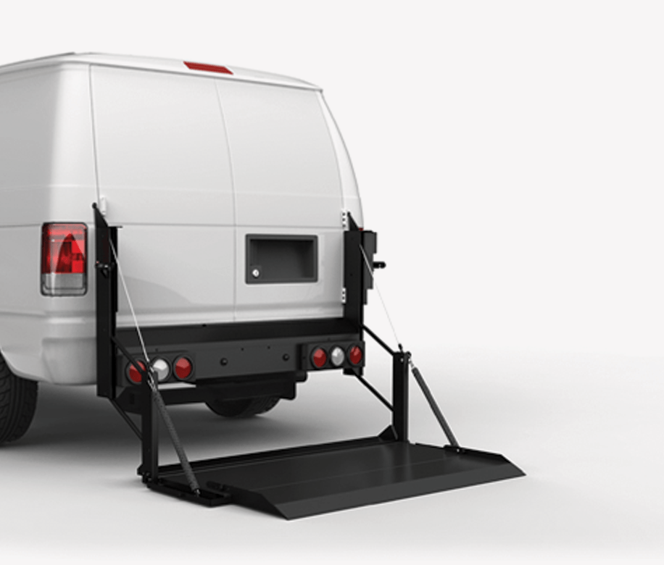
Company Name
Agent Signature
Bid Amount per Van
Total Amount

Attachment “A”

- Equal Employment Opportunity-All contracts shall contain a provision requiring compliance with E.O. 11246, “Equal Employment Opportunity,” as amended by E.O. 11375, “Amending Executive Order 11246 Relating to Equal Employment Opportunity,” and as supplemented by regulations at 41 CFR part 60, “Office of Federal Contract Compliance Programs, Equal Employment Opportunity, Department of Labor.”

- Debarment and Suspension (E.O.s 12549 and 12689) No contract shall be made to parties listed on the General Services Administration’s List of Parties Excluded from Federal Procurement or Non procurement Programs in accordance with E.O.s 12549 and 12689, “Debarment and Suspension.” This list contains the names of parties debarred, suspended, or otherwise excluded by agencies, and contractor declared ineligible under statutory or regulatory authority other than E.O. 12549. Contractors with awards that exceed the small purchase threshold shall provide the required certification regarding its exclusion status and that of it’s principal employees.

